# JobQuest Navigator - Meetings

**Meeting Title:** Capstone Project - JobQuest Navigator

**Date:** **Time:** 31-05-2025

**Start Time:** 9:30 a.m **End Time**: 1:20 p.m

**Location/Platform:** Microsoft Teams

**Facilitator:** Maria Soto

**Attendees:**Maria Soto Ortiz  
Shruti Amit Vasanwala  
Zhihuai Wang

## Agenda

## Discussion & Notes

|  |  |  |  |
| --- | --- | --- | --- |
| **Topic** | **Action** | **Owner** | **Status** |
| Epic Diagrams | Develop a detailed diagram and define the scope for each Epic to provide clarity and enable the team to begin work effectively | Ishan Aakash  Maria Soto  Shruti Vasanwala Zhihuai Wang | In progress |
| User Interface (UI) Design Improvements | Progress continues the Job Mapping Interface, with ongoing refinement of UI elements and user experience to align with project goals. | Shruti Vasanwala | In progress |
| Project Progress Monitoring | Implementation daily 15-minute micro-sessions to review progress, address blockers, and ensure continuous alignment across the team | Maria Soto | Done |
| Validation of Epics and Project Progress | Review each team member’s work and incorporate new information to advance the project | Zhihuai Wang Shrutti Vasanwala Maria Soto Ishan Patel | In progress |

## Decisions Made

* Checked all members working on GitHub. We are going to use a cursor as a tool to improve our management with GitHub.
* Shrutti Vasanwala continues working with IU interface.
* Zhihuai Wang continues working on Epic 1 devolopment the scrapping information from **Adzuna** Job API.

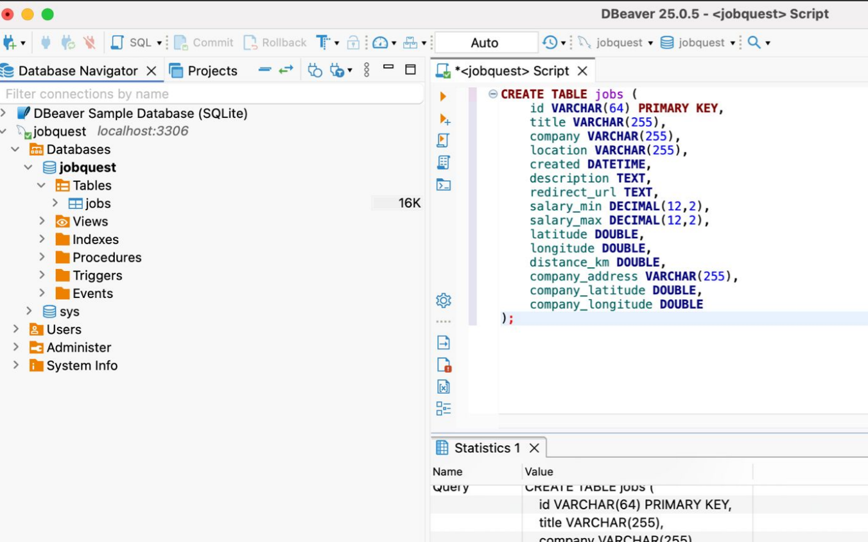

## Action Items & Next Steps

|  |  |  |  |
| --- | --- | --- | --- |
| **Topic** | **Action** | **Owner** | **Deadline** |
| Microservices for each epic | Each team member is responsible for reviewing the microservices associated with their respective epics and developing or contributing to them throughout the week | Zhihuai Wang Shrutti Vasanwala Maria Soto Ishan Patel | 07-06-2025 |

## Next Meeting

**Date/Time:** 02-06-2025